**CHEMICALS OF LIFE**

These are compounds needed to maintain life of living organisms. They are divided into two groups, i.e.

1. Inorganic compounds e.g. water, vitamins, salts, acids and roughages.
2. Organic compounds e.g. carbohydrates, lipids, proteins and nucleic acids.

**WATER**

It is the most important inorganic compound in life and most abundant within living organism.

A human cell contains about 80% water and the whole body has over 60% water.

Water is formed when two hydrogen atoms combine with an oxygen atom by sharing electrons. The shape of a water molecule is triangular and the angle between the nuclei of atoms is approximately 1050

Water molecules form weak hydrogen bonds with other water molecules nearby and its bonds give it the unique properties.

http://www.chemguide.co.uk/atoms/bonding/shapeh2o.GIF

**Properties of water**

1. It is liquid at room temperature.
2. It has a high heat capacity therefore much energy is used to raise its temperature because it is used to break the hydrogen bonds which restrict the mobility of the molecules. As a result water is relatively slow to heat up or to cool down thus a high heat capacity.
3. Water expands as it freezes unlike other liquids which contract on cooling.
4. Water reaches its maximum density above its freezing point at 4oC hence when water freezes, the ice formed is less dense than the water and hence floats on top of the surface. In this way, ice insulates water below making it less dense and able to float hence the water will be warmer than the air above.
5. Water has a high surface tension. Surface tension is the force that causes the surface of a liquid to contract so that it occupies the least area. It is high due to the fact that molecules are oriented so that most hydrogen bonds point inwards towards other water molecules.
6. It has a high latent heat of fusion i.e. much heat must be removed before freezing occurs.
7. It has high adhesive and cohesive properties preventing it from breaking under tension.
8. It is colourless and transparent.
9. It has a low viscosity i.e. water molecules slide over each other very easily.
10. It dissolves more substances than any other liquid i.e. it is a universal solvent.

**Functions of water**

* It is a component of cells
* It is a solvent and a medium of transport
* It is a reagent in hydrolysis
* It enables fertilization by swimming gametes
* It enables dispersal of seeds, fruits, gametes and larvae stages in aquatic organisms.
* It is important in transpiration in plants.
* It is important in translocation in plants.
* It enables germination to proceed by activating enzymes, transporting hydrolyzed stored food, swelling and breaking open the testa.
* It is involved in Osmo-regulation in animals
* It enables cooling by evaporation as a result of sweating and panting.
* It is a component of lubricants at joints e.g. the synovial fluid.
* It offers support in hydrostatic skeleton.
* It offers protection as a component of mucus and tears.
* It enables migration to occur as a result of river flow or ocean currents.

**QUESTION: *HOW DO THE PROPERTIES OF WATER RELATE TO ITS BIOLOGICAL ROLE?***

1. Water is transparent and this allows light penetration in aquatic habitats to enable photosynthesis of aquatic autotrophs and visibility of aquatic animals.
2. Water has a low viscosity and this allows for smooth flow of water and other dissolved substances in an aquatic medium for easy transport.
3. It has a high surface tension providing support to aquatic organisms and allowing movement of living organisms on water surface.
4. Has a high latent heat of vaporization hence a cooling effect on the body surface since evaporation of water from the body of an organism draws out excess heat.
5. It has a high boiling point thus provides a stable habitat and medium since a lot of heat which is not normally provided in the natural environment is needed to boil the water.
6. It has a high latent heat of fusion and hence a low freezing point thus providing a wide range of temperature for survival of aquatic organisms since it prevents freezing of cells and cellular components.
7. It has a high specific heat capacity which minimizes drastic temperature changes in biological systems and provides a constant external environment for many plant cells and aquatic organisms.
8. It has a maximum density at 4o C hence ice floats on top of water insulating the water below hence increasing the chances of survival of aquatic organisms below the ice.
9. Water is liquid at room temperature providing a liquid medium for living organisms and metabolic reactions and a medium of transport.
10. It has high adhesive and cohesive forces creating enough capillarity forces for transport in narrow tubes of biological systems.
11. It is a universal solvent hence providing a medium for biochemical reactions.
12. Water is a polar molecule allowing solubility of polar substances, ionization or dissociation of biochemical substances.
13. Water is incompressible thus providing support in hydrostatic skeleton and herbaceous stems.
14. Water is neutral hence does not alter the pH of cellular components on their environment.
15. A water molecule is relatively small for easy and fast transport across a membrane.

**QUESTION: *OUTLINE THE ROLE OF MINERALS AND IONS IN BIOLOGICAL SYSTEMS.***

1. They are components of smaller molecules e.g. phosphorus is contained in ATP and iodine is contained in thyroxin, etc.
2. They are constituents of large molecules e.g. proteins contain nitrogen and sulphur, phospholipids contain phosphorus, nucleic acids contain nitrogen and phosphorus, etc.
3. They are components of pigments e.g. haemoglobin and cytochromes which contain ion, chlorophyll contain magnesium, etc.
4. They are metabolic activators e.g. activates glucose before it is broken down in cell respiration, calcium ions activate ATPase enzyme during muscle contraction.
5. They determine the anion, cation balance e.g. Na+, K+ and Ca+ are important in transmission of impulses and muscle contraction.
6. They determine the osmotic pressure and water potential so that it does not fluctuate beyond narrow limits e.g. Na+, K+ and Cl- are involved in water balance in the kidneys.
7. They are constituents of structures in cell membranes, cell walls, bones, enamel and shells.

**CARBOHYDRATES**

These comprise of a large group of organic compounds which contain C,H and O. they have a general formula CX(H2O)Y though some do not conform to it e.g. deoxyribose C5H10O4.

**Main functions of carbohydrates**

* They are a primary source of energy being oxidized in the body to release energy.
* They are structured components of cells e.g. cellulose making up the cell wall.
* They are determinants of osmotic potential of body fluids therefore maintain blood pressure.
* They are recognized units on the surface of body cells, i.e. they are component structures of the surface cell membranes recognized by antibodies.

**Types of carbohydrates**

1. Monosaccharides (single unit sugars)
2. Disaccharides (double unit sugars)
3. Polysaccharides (several unit sugars)

**MONOSACCHARIDES**

Monosaccharides (mono=one, saccharide= sugar) are substances consisting of one molecule of sugar. They are also known as simple sugars.

**Properties of monosaccharides**

* They have a sweet taste
* They dissolve in water
* They form crystals
* They have a low molecular mass
* Can pass through a selectively permeable membrane.
* They change the colour of benedict’s solution from blue to orange when boiled with the solution thus they are known as ***reducing sugars.***

Monosaccharides are named using a suffix ‘ose’. They contain either an aldehyde group (CHO) and are called aldoses or they contain a ketone group (C=O) and are called ketones. Monosaccharides have a general formula (CH2O) n where:

* n=3 (triose sugar)
* n=5 (pentose sugar)
* n=6 (hexose sugar)
* n=7 (heptose), etc.

The most frequent monosaccharides are the hexose sugars; glucose, fructose and galactose.

**HEXOSE SUGARS**

These are sugars with molecular formula C6H12O6 and structural formulae as shown below:

Glucose (aldose)

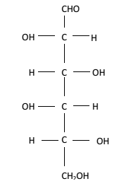 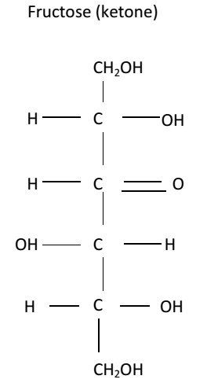

Glucose can exist in a number of isomers where it has different structural formulae remaining with the same molecular formulae.

**Isomers of glucose**

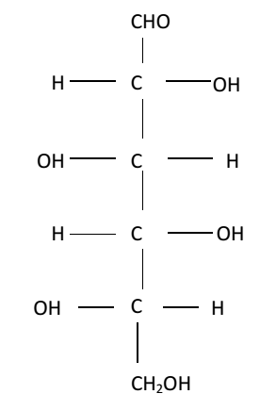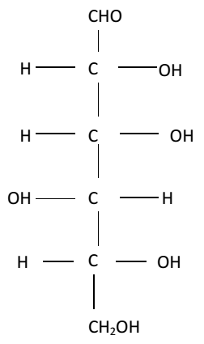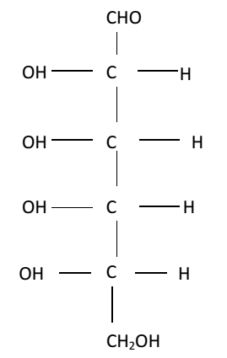

The hexose sugars can exist in straight or chain form as shown above or in ring form as shown below:

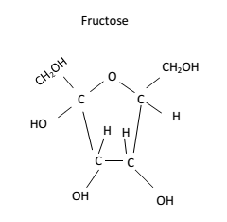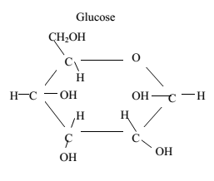

**PENTOSE SUGARS**

They have 5 carbon atoms. They are found in nature as ribose and deoxyribose. They exist in straight and ring forms.

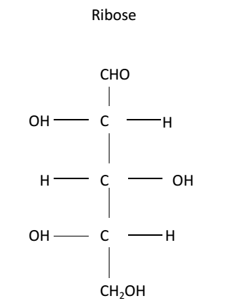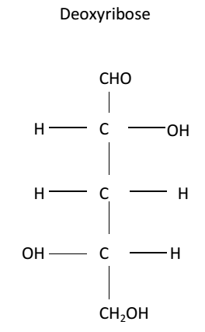

Ring forms

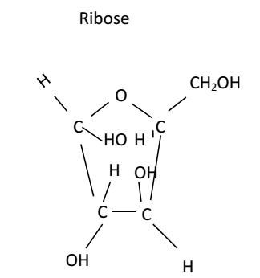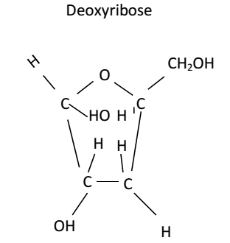

Ribose occurs in co-enzymes, adenosine triphosphate (ATP) and ribonucleic acid (RNA). Deoxyribose occurs in DNA (Deoxyribo Nucleic Acid).

**TRIOSE SUGARS**

They contain 3 carbon atoms. The two occurring trioses are glyceraldehyde and dehydroxyacetone. Both of them are found in plant and animal cells playing a role in carbohydrate metabolism.

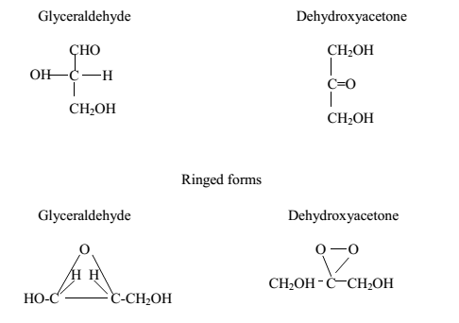

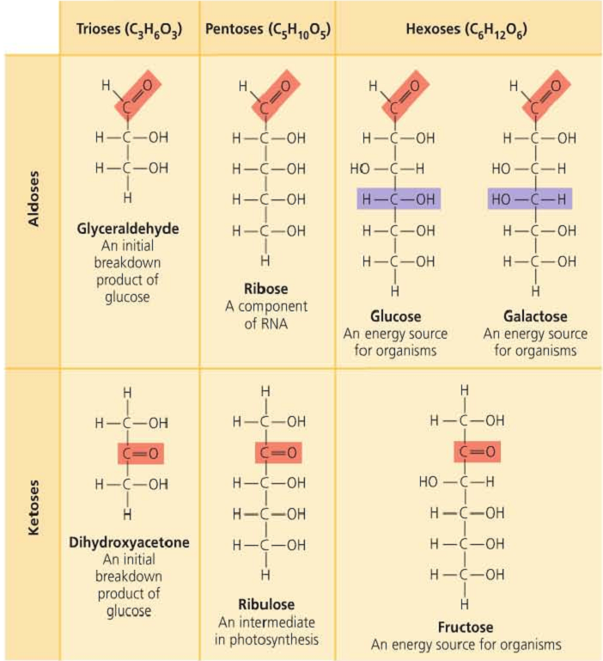

**DISACCHARIDES**

Monosaccharides combine together in pairs to form disaccharides. This union involves loss of a water molecule and therefore the reaction is a condensation reaction. The bond formed is a glycosidic bond. The most common disaccharides are:

1. Maltose formed from linkage of two glucose molecules. It is common in most germinating seeds and cereals.
2. Sucrose from union of glucose and fructose. It is the main form in stems of sugar canes and roots of sugar beets which are sources of commercial sugars.
3. Lactose resulting from the union of glucose and galactose and found in milk.

**The disaccharides have the following properties:**

1. They are sweeter than monosaccharides
2. They can be crystallized
3. They are soluble in water
4. Do not change the colour of Benedict’s solution when heated with it (apart from maltose)- they are known as non-reducing sugars
5. Can be broken down into simple sugars by dilute mineral acids and enzymes

**Note:** Maltose can also be formed as a product of starch hydrolysis.

**Formation of maltose**

**C6H12O + C6H12O -------- C12H22O + H2O**

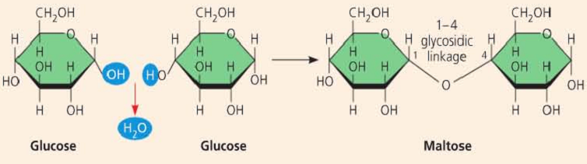

**Formation of sucrose**

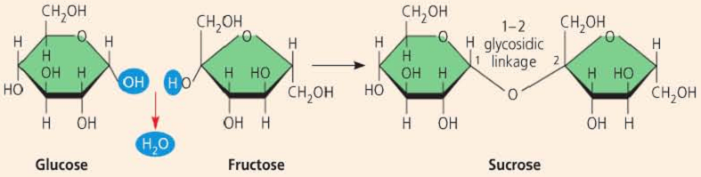

**POLYSACCHARIDES**

Many monosaccharides may combine by condensation reactions to form polysaccharides. A number of monosaccharides which combine may be variable and the chain can be branched or unbranched.

**Properties of polysaccharides include:**

* Are not sweet
* Do not dissolve in water
* Cannot be crystallized
* They have a high molecular mass.
* They are non-reducing sugars

The chains may be folded to make them compact which are ideal for storage. Such a large size of the molecules makes them insoluble in water and suitable for storage as they exert no osmotic influence and do not easily diffuse out of the cell.

Starch is the main storage material in green plants while glycogen is for animals.

Upon hydrolysis, polysaccharides are broken down into their constituent monosaccharides.

Not all polysaccharides are used for storage e.g. cellulose is a structural polysaccharide giving support and strength to the cell walls.

**STARCH**

It is found in plant parts in form of granules. It is a reserve food formed from any excess glucose during photosynthesis.

It is common in seeds e.g. maize where it is the main food supply during germination.

**Structure:**

It is a polymer of α-glucose molecules which are held by glycosidic bonds forming chains of α-glucose units which get folded or coiled into a helix.

Starch has two components i.e. amylose and amylopectin, that is, 20% amylose, 79% amylopectin and 1% other substances e.g. phosphates and fatty acids.

Amylose stains deep blue with iodine while amylopectin stains red to purple with iodine.

Amylose is structurally unbranched while amylopectin is branched.

**QUESTION: *HOW DOES THE STRUCTURE OF STARCH RELATE TO ITS ROLES?***

* It is a polymer of α-glucose molecules hence a large molecule making it relatively insoluble in water hence an ideal storage molecule.
* The α-glucose molecules are held by glycosidic bonds which can be broken down to free glucose molecules from the stored starch for ATP synthesis during respiration.
* The starch molecule is coiled into a helix with a hydroxide group projecting interiorly making it insoluble in water hence exerts no osmotic effects in cells and is ideal for storage.
* The chains of α-glucose units can be folded to form starch grains for easy storage.

**GLYCOGEN**

It is a major polysaccharide storage material in animals. It stored mainly in the liver and muscles. It is also made up of α-glucose molecules and exists as granules. However its chains are shorter (10-20 glucose units) and is more branched. Glycogen is more soluble than starch.

**CELLULOSE**

It comprises up to 50% of a plant cell wall and in cotton it makes up to 90%.

It is a polymer of about 10000 β-glucose molecules forming long unbranched chains which are parallel to each other with cross linkages between them which give it its stability and a good structural material.

**Structure:**

It is a polymer with straight chains of β-glucose units held by glycosidic bonds with the OH group projecting out wards from each chain forming cross linkages of hydrogen bonds with adjacent chains.

The cross linking binds the chains together which associate to form micro fibrils that are arranged in larger bundles to form macro fibrils.

**Note:** starch lacks the structural properties possessed by cellulose because it lacks cross linkages.

The stability of cellulose makes it difficult to digest and therefore not a good source of food to animals except those which have cellulase producing microorganisms which live in them in a symbiotic way e.g. in the rumen of cattle, goats, sheep, etc.

**Uses of cellulose**

* Rayon produced form cellulose extracted from wood is used in the manufacture of tyre cords.
* Cotton is used in the manufacture of fibres and closes.
* Cellophane used in packaging is produced from cellulose.
* Paper is a product of cellulose.
* Celluloid used in photographic films is also a derivative of cellulose.

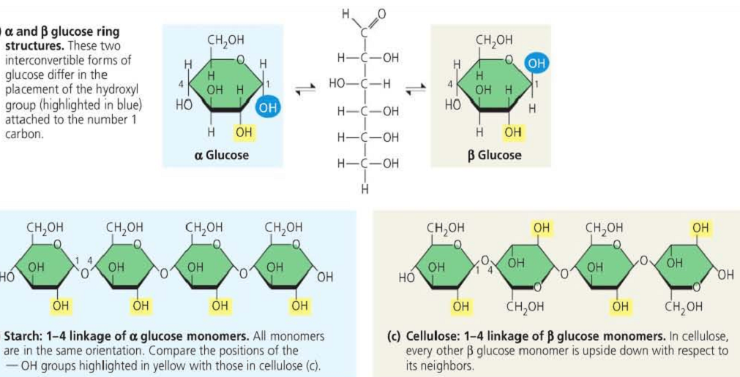

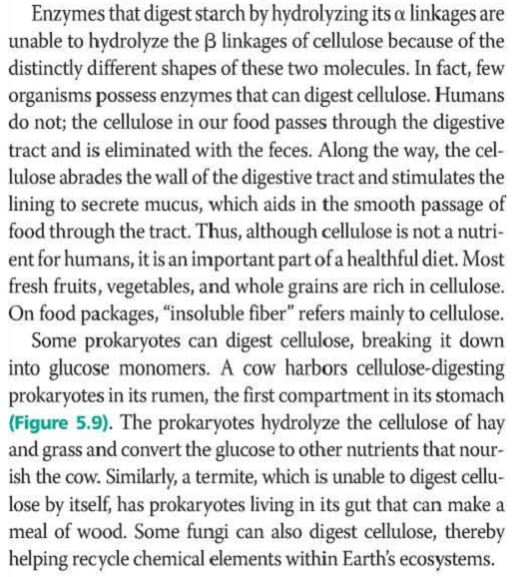

**QUESTION: *HOW DOES THE STRUCTURE OF CELLULOSE RELATE TO ITS ROLES***

1. Cellulose is a polymer of straight chains of β-glucose units held by glycosidic bonds with OH groups projecting outwards from each chain forming cross linkages of H bonds with adjacent chains.
2. The cross linking binds the chains together offering much tensile strength.
3. The micro fibrils in cell walls are arranged in several layers offering protection to the plant cell preventing it from bursting when water enters by osmosis.
4. The arrangement of micro fibrils in cell walls contributes to turgidity hence offering support.
5. The parallel layers of cellulose are fully permeable to water and solutes.
6. The arrangement of micro fibrils determines the shape of the cells and hence plant organs since it determines the direction in which cells expand as they grow.
7. The glycosidic bonds holding the β-glucose units in cellulose can be broken down in presence of enzyme cellulose so that a free glucose molecule can be respired.

**OTHER POLYSACCHARIDES**

1. **Chitin:**

Chemically and structurally, chitin resembles cellulose but differs in possessing an acetyl group (NH-OCH3) instead of one of the OH groups. Like cellulose, it has a structural function and is a major component of exoskeleton of insects and crustacea. It is also found in fungal cell walls.

1. **Insulin:**

It is a polymer of fructose and found as a storage carbohydrate in some plants.

1. **Mucopolysaccharides:**

This group includes hyaruronic acid which forms part of the matrix of vertebrae connecting tissue. It is found in cartilage, bones, vitreaous humor of the eye, synovial fluid, etc.

Heparin, an anti-coagulant also contains mucopolysaccharides.

**FOOD TESTS ON CARBOHYDRATES**

* + - 1. **Test for reducing sugars**

The reagent used is Benedict’s solution (blue) or Fehling’s solution (blue). Boiling is required.

|  |  |  |
| --- | --- | --- |
| **Procedure** | **Observation** | **Conclusion** |
| To 1 cm3 of food solution, add 1 cm3 of Benedict’s solution and boil. | Colourless or turbid solution turned to a blue solution, then to a green solution, to a yellow precipitate, to orange precipitate and to a brown precipitate on boiling. | Little or  Moderate or  Much or  Too much; reducing sugars present. |
| Colourless or turbid solution turned to a blue solution which persists on boiling. | Reducing sugars absent. |

If Fehling’s solution is used, the change is from blue solution to orange precipitate if reducing sugars are present. It remains a blue solution if they are absent.

**Examples of reducing sugars include:**

1. Glucose (present in grapes)
2. Fructose (present in many edible fruits)
3. Galactose (present in milk)
4. Maltose (present in germinating seeds)

**The conclusions based on colour changes are according to the following observations**:

Blue ***solution***- no sugars

Green ***solution***- little sugars present

Yellow ***precipitate***- moderate sugars present

Orange ***precipitate***- much sugars present

Brown ***precipitate***- too much reducing sugars present

* + - 1. **Test for non-reducing sugars**

|  |  |  |
| --- | --- | --- |
| **procedure** | **Observation** | **conclusion** |
| To 1 cm3 of food solution add 1 cm3 of dilute hydrochloric acid and boil, cool under water then add 1 cm3 of sodium hydroxide solution, followed by 1 cm3 of Benedict’s solution and boil. | Colourless or turbid solution turned to a blue solution, then to a green solution, to a yellow precipitate and to a brown precipitate on boiling. | Little or  Moderate or  Much or  Too much; non-reducing sugars present. |
| Colourless or turbid solution turned to a blue solution which persists on boiling. | Non-reducing sugars absent. |

**Note:**

1. When boiled with dilute HCl, the non- reducing sugars breaks down into the reducing sugars.
2. Sodium hydroxide solution or sodium hydrogen carbonate powder is added to neutralize the acid so that Benedict’s solution can work.

**Examples of non-reducing sugars include:**

* + 1. Sucrose (present in sugar cane)
    2. Lactose (present in milk)
       1. **Test for starch:**

The reagent used is iodine which is a brown or yellow solution).

|  |  |  |
| --- | --- | --- |
| **Procedure** | **Observation** | **Conclusion** |
| To 1 cm3 of food solution, add 3 drops of iodine solution. | Colourless or turbid solution turned to a black or blue-black or blue solution or brown solution with black specks. | Much or moderate or little starch present. |
| Colourless or turbid solution turned to a yellow or brown solution. | Starch absent. |

**LIPIDS**

These are large group of organic compounds. Like carbohydrates, they contain carbon, hydrogen and oxygen but the proportion of oxygen is smaller than in carbohydrates hence they are more reduced than the carbohydrates.

Lipids are insoluble in water.

They are of two types i.e. fats and oils. Fats are solid at room temperature while oils are liquids at room temperature.

Lipids are made of fatty acids and glycerol. Glycerol has 3 OH groups and each combines with a separate fatty acid to form a lipid chemically known as a triglyceride. This is a condensation reaction that leads to liberation of 3 water molecules.

**Formation of a triglyceride**

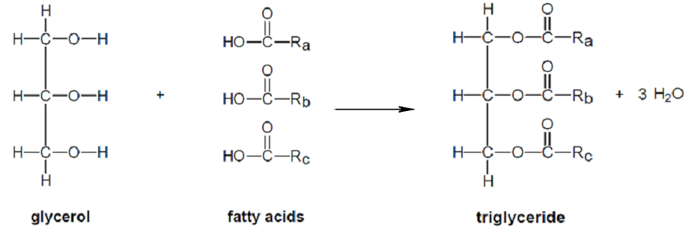

**Question: *using the structural formula:***

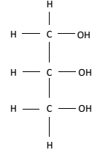

For glycerol, and molecular formula CH3(CH2)nCOOH for a fatty acid, show the formation of a triglyceride from fatty acids and glycerol.

**FATTY ACIDS**

All occurring lipids have glycerol and therefore it is the nature of the fatty acids which determines the characteristics of any particular lipid. All fatty acids have a carboxyl group (COOH), the reminder of the molecule being a hydro carbon chain of varying length.

These chains may possess one or more double bond in which case it is said to be unsaturated. If it possesses no double bonds, it is said to be saturated.

|  |  |  |  |
| --- | --- | --- | --- |
| Nature of fatty acid | General formula | Saturated/unsaturated | Occurrence |
| 1. Butyric acid | C3H7COOH | Saturated | Butter fat |
| 1. Linoleic acid | C17H31COOH | Unsaturated | Seed oil |
| 1. Oleic acid | C17H33COOH | Unsaturated | All fats |
| 1. Palmitic acid | C15H31COOH | Saturated | Animal & veg fat |
| 1. Selotic acid | C25H51COOH | Saturated | Wood oil |
| 1. Arachidic acid | C19H39COOH | Saturated | P.nut oil |

From the table, it is seen that the hydrocarbon chains may be very long forming long tails which extend from the glycerol molecules. These trails are hydrophobic (water repelling) which makes the lipids insoluble in water.

**Question: *explain why lipids are insoluble in water?***

**PHOSPHOLIPIDS**

These are lipids in which one of the fatty acid groups is replaced by phosphoric acid.

CH2O-OC-fatty acid

CHO-OC-fatty acid

CH2O- phosphoric acid

Phosphoric acid is hydrophilic in contrast to the remainder of the molecule, having an end attracting water while the other end repelling it gives the phospholipid its characteristics as one the components of the cell membrane.

**WAXES**

These are formed by combination of fatty acids with an alcohol other than glycerol. Their major function is water proofing in plants and animals. They are also storage compounds in seeds e.g. castor oil seeds.

**STEROIDS**

These are related to lipids e.g. cholesterol in animals used to synthesize sex hormones. Other steroids include vitamin B and bile acids.

**FUNCTIONS OF LIPIDS**

**Structural:**

1. They are components of the plasma/cell membrane.
2. They form subcutaneous fat in the dermis of the skin hence insulating the body since they are poor conductors of heat.
3. They are components of the waxy cuticle in plants and insects there by preventing water loss (desiccation).
4. They form a component of the myelin sheath of nerves hence playing a role in the transmission of impulses.
5. They protect delicate organs e.g. the heart and kidney from injury.
6. They coat on fur of animals enabling it to repel water which would otherwise wet the organism.
7. They are component of adipose tissue.

**Physiological:**

1. They provide energy through oxidation.
2. They are solvents for fat soluble vitamins (ADEK).
3. They are a good source of metabolic water to desert animals, young birds and reptiles while still in their shells.
4. They are a constituent of the brown adipose tissue which provides heat for temperature regulation (thermogenesis).

**Other functions:**

1. Some lipids provide a scent in plants which attracts insects for pollination.
2. Wax is used by bees to construct honey combs.
3. Wax from bees is used in the manufacture of candles.

**QUESTION: *WHAT PROPERTIES DO LIPIDS POSSES AS STORAGE COMPOUNDS?***

1. They are compact taking up little space.
2. They are insoluble in water hence cannot be lost in solution.
3. They are light to keep the weight to a minimum and allow buoyancy.
4. They have a high calorific energy value.
5. They have a high hydrogen-oxygen content hence can yield a lot of water on oxidation.

**TESTS FOR LIPIDS**

They are tested for using the emulsion test or the grease spot (translucent spot) test.

1. **Sudan III test:**

|  |  |  |
| --- | --- | --- |
| **Procedure** | **Observation** | **Deduction** |
| To 1 cc of food solution, add 1 cc of Sudan III and shake. | A turbid solution turns a red emulsion. | Lipids present. |
| Turbid or colourless solution remains a turbid or colourless solution. | Lipids absent. |

1. **The emulsion test:**

The reagents used are ethanol and water.

|  |  |  |
| --- | --- | --- |
| **Procedure** | **Observation** | **Deduction** |
| To 1 cc of food solution, add 1 cc of ethanol and shake. Then add 5 drops of water and shake. | A turbid solution turns to a cream emulsion | Lipids present. |
| Turbid or colourless solution remains a turbid or colourless solution. | Lipids absent. |

1. **Translucent spot test:**

|  |  |  |
| --- | --- | --- |
| **Procedure** | **Observation** | **Conclusion** |
| Add 2 drops of test solution on a piece of filter paper.  Allow to dry and observe under light. | A translucent spot or patch is left on the paper. | Lipids present |
| No translucent spot is formed on the paper. | Lipids absent. |

**PROTEINS**

These are organic compounds of large molecular mass and insoluble in water. In addition to C,H and O, they always contain N, usually S and sometimes P.

Whereas there are few carbohydrates and fats, the number of proteins is limitless e.g. a single bacterium may have around 800 types of proteins while man has 10,000 types. This is because there are several amino acids which may join in different patterns hence forming the various types of proteins.

Proteins are specific to each species hence determine the character of the species.

Proteins are not stored in the organism except in eggs and seeds where they are used to form new tissues.

Proteins form the structural basis of all living cells.

Their building blocks are the amino acids.

**AMINO ACIDS**

These are groups of many chemicals of which around 20 occur in proteins. They contain an amino group (NH2) and a carboxyl group (COOH). Most amino acids have one of each and are therefore neutral but a few have more amino groups than carboxyl making them alkaline or may have more carboxyl than amino groups making them acidic.

**Structure of amino acids**

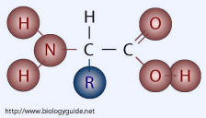

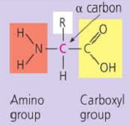 **Where** R is a variable

Amino acids are soluble in water and ionize to form ions.

The carboxyl end of the amino acid is acidic in nature. It will ionize in water to give H+. This will make the COOH group negatively charged.

The amino end (NH2) is basic in nature. It attracts the H+ in solution making it positively charged. The ion is now dipolar i.e. having a negative and a positive pole. Such ions are called zwitter ions i.e. the negative and positive charges exactly balance and the amino acid ion has no overall charge i.e.

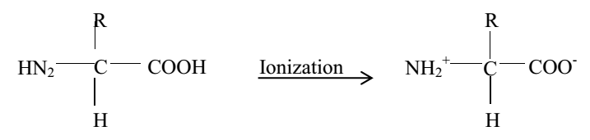

Zwitter ion (no overall charge)

Therefore in acidic solutions, an amino acid acts like a base and in alkaline solutions, it acts as an acid. In neutral conditions found in the cytoplasm of most living organisms, the amino acid acts as both.

Amino acids therefore show both acidic and basic properties i.e. they are amphoteric.

The overall charge of the amino acid depends on the pH of the solution.

At some characteristic pH, the amino acid has no overall electric charge i.e. it exists as a zwitter ion. This pH is called the isoelectric point of an amino acid.

If the pH falls below the iso-electric point i.e. the solution becomes more acidic, H+ are taken up by the carboxyl ion. This reduces the concentration of the H+ in solution making the solution less acidic and the amino acid gains an overall positive charge.

If the pH rises above the iso-electric point i.e. it becomes less acidic or more alkaline, hydrogen ions are lost by the amino group. This increases the concentration of free H+ in the solution making it more acidic and the amino acid gains an overall negative charge. Therefore being amphoteric, amino acids are buffers.

**NOTE:** a buffer solution is one which resists the tendency to alter its pH even when small amounts of acid or base are added to it.

**Questions: *how do amino acids act as buffer solutions?***

**TYPES OF AMINO ACIDS**

1. **Essential Amino acids**

These are amino acids that cannot be synthesized by the body and therefore got from the diet that the organism feeds on. They include:

* Histidine
* Isoleucine
* Leucine
* Proline
* Phenylalanine
* Valine
* Arginine
* lysine
* Methionine
* Tryptophan

1. **Non-Essential amino acids**

These are amino acids that are synthesized by the body through a process called transamination. They include:

* Tyrosine
* Alanine
* Glycine
* Serine
* Theonine
* Cystine
* Cystein
* Aspartic acid
* Glutamic acid
* Asparagine

Proteins can be classified into: **first class proteins** which contain all the essential amino acids e.g. from beans and **second class proteins** which are deficient of one or more essential amino acid.

**FORMATION OF POLYPEPTIDES**

They are formed as a result of condensation reaction between the amino group of one amino acid and the carboxyl group of another amino acid to form a dipeptide.

Further combinations of this type extend the length of the chain to form a polypeptide which usually contains many amino acids.

The shape of the polypeptide molecule is due to four types of bonding which occur between the various amino acids in the chain. These bonds include:

1. Disulphide bond:

It is formed between sulphur containing groups on any two cysteine molecules.

1. Ionic bond:

It is formed between NH3+ and COO- groups.

1. Hydrophobic interactions:

These are interactions between non polar R groups which cause the proteins to fold as hydrophobic side groups.

**The polypeptide chain showing 3 types of bonding**

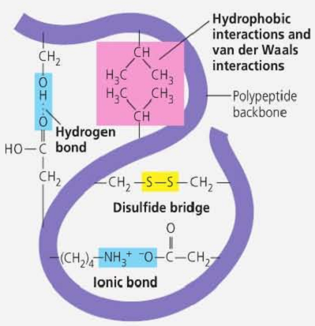

**PROTEIN STRUCTURES**

There are 3 main protein structures i.e. primary structure, secondary structure and tertiary structure.

**Primary structure**

It is a sequence of amino acids in a polypeptide chain. It is made up of 2 polypeptide chains held together by di-sulphide bridges. The sequences of amino acids of a protein dictate its biological functions. Examples of primary structures are insulin and lysosomes.

**Secondary structure**

It is maintained by many ionic bonds which are formed between neighbouring COO- and NH3+ groups.

The hydrogen atoms of the NH3+ group of one amino acid is bonded to the oxygen atom of the COO- group of another amino acid. Such structures are found in vertebrate skins, horns, nails, claws, beaks and feathers.

Its hardness and stretch ability vary with a degree of cross linkage between di sulphide bridges and neighbouring chains. They are joined together by hydrogen bonds between adjacent chains.

**Tertiary structures**

The polypeptide chain coils extensively forming a compact globular shape. This structure is maintained by interaction of the four types of bonds i.e. ionic, hydrogen, di sulphide bonds and hydrophobic interactions.

The hydrophobic interactions are quantitatively the most important and occur when a protein falls to shield the hydrophobic side groups from the aqueous surrounding and at the same time exposing hydrophobic side chains.

**Quaternary structure**

It is a combination of several polypeptide chains clumped together and associate with non-protein parts to form complex proteins e.g. in haemoglobin.

**TYPES OF PROTEINS**

1. **Fibrous proteins (**plays structural roles**)**

These form long chains which may run parallel to one another being linked by cross bridges. They are very stable molecules and have structural roles within the organism e.g. collagen in made of such proteins.

It has a primary structure which is a repeat of tri peptide sequence (glycine, proline and alanine) and forms a long unbranched chain.

1. **Globular proteins (**plays metabolic roles**)**

They have a highly irregular sequence of amino acids in their polypeptide chains. Their shape is compact and globular. All enzymes are globular proteins. Others include hormones and haemoglobin.

1. **Conjugated proteins**

These are proteins which incorporate other chemicals within their structure. The non-protein part is the prosthetic group and plays a virtual role in the functioning of the proteins e.g.

|  |  |  |
| --- | --- | --- |
| **Name of protein** | **Where it is found** | **Prosthetic group** |
| Haemoglobin | Blood | Haem (iron) |
| Mucin | Saliva | Carbohydrate |
| Casein | Milk | Phosphoric acid |
| Cytochrome oxidase | Electron carrier path way | Copper |
| Nucleoplasm | Ribosomes | Nucleic acid |

**QUESTION: *HOW DOES THE MOLECULAR STRUCTURE OF PROTEINS RELATE TO THEIR ROLES?***

1. Some proteins have a structural function, these are fibrous proteins with a secondary structure insoluble in water and physically tough e.g. collagen in connective tissues, bone, tendons and cartilage. Other structural proteins include keratin in feathers, nails, hair, horns, beaks and skin.
2. Some proteins function as enzymes. These have a globular structure and are soluble in water e.g. digestive enzymes like pepsin, respiratory and photosynthetic enzymes.
3. Some proteins function as hormones regulating metabolic processes. These are globular and soluble in water e.g. insulin which regulates metabolic activity.
4. Some proteins functions as respiratory pigment. These are globular proteins with a quaternary structure that increases their surface area for transport or storage of respiratory gases e.g. haemoglobin which transports oxygen in blood and myoglobin that stores oxygen in muscles.
5. Some proteins are involved in transport and are globular with primary or tertiary structures e.g. serum albumen that transports fatty acids and lipids in blood.
6. Some proteins are involved in immunological responses hence protecting the body. These are globular e.g. antibodies, fibrinogen and thrombin.
7. Some proteins are contractile e.g. they are fibrous with a secondary structure e.g. myosin and actin filaments in muscles.
8. Storage proteins are toxins and soluble and water with a globular structure e.g. snake venom, bacteria toxins, etc.
9. Some proteins are insoluble in water e.g. ovalbumin that occurs in egg white, casein in milk, etc.
10. Globular proteins form colloidal suspensions that hold molecules in position within cells e.g. proteins in the cytoplasm of most cells where they are soluble in water and have a large surface area.
11. Globular proteins in blood are buffers since they are soluble in water.

**DENATURATION OF PROTEINS**

The dimensional structure of the protein is due to weak ionic and hydrogen bonds. Any agent which breaks these bonds causes the three dimensional shape to be changed to a more fibrous form. This process is known as denaturation.

In case the actual sequence of the amino acid is not altered but only the overall shape of the molecule is changed.

**Factors causing protein denaturation**

|  |  |  |
| --- | --- | --- |
| **Factor** | **Explanation** | **Example** |
| 1. Heat | Causes the atoms of the protein to vibrate more thus breaking the hydrogen and ionic bond. | Coagulation of albumen ( egg white becomes more fibrous). |
| 1. Acids | Addition of hydrogen ions in acids combine with COO- of amino acids and form COOH ionic bonds are hence broken. | Souring of milk by acid and lowering pH of casein making it insoluble. |
| 1. Alkalis | Reduced number of H+ cause NH+ group to loose H+ to form NH2 therefore ionic bonds broken. | Souring of milk by alkalis. |
| 1. Inorganic chemicals | Ions of heavy metals e.g. mercury and silver combine with COO- groups destructing the ionic bonds. | Enzymes are inhibited by being destructed in presence of ions e.g. cytochrome oxidase. |
| 1. Organic chemicals | Organic solvents alter hydrogen bonding with a protein. | Alcohol denatures certain bacterial proteins. This is what makes it useful for sterilization. |
| 1. Mechanical force | Physical movement can break hydrogen bonds. | On stretching a hair, the hydrogen bonds in the keratin helix is extended and hair stretches. |

**Functions of proteins**

|  |  |  |
| --- | --- | --- |
| VITAL ACTIVITY | PROTEIN EXAMPLE | FUNCTION |
| 1. Nutrition | * Digestive enzymes e.g. trypsin, amylase, etc. * Fibrous proteins in grana lamellae * casein | * catalyses, hydrolysis of proteins to peptides. * Helps to arrange chlorophyll molecules to receive unlimited light. * Assists in transporting of food in filter feeder. * Storage of proteins in milk. |
| 1. Respiration and transport. | * Haemoglobin. * Myoglobin * Prothrombin/fibrinogen * Antibodies. | * Transport of oxygen. * Stores oxygen in muscles. * Required for blood clotting. * Essential for defense. |
| 1. Growth | Hormones e.g. thyroxine | Controls growth and metabolism. |
| 1. Excretion | Enzymes e.g. urease | Catalyzes reaction in ornithine cycle and helps in protein break down and urea formation |
| 1. Support and movement | Actin/myosin | Makes it easy for muscle contraction. |
| Collagen | Gives strength with flexibility in tendons and cartilage. |
| Keratin | Tough for protection e.g. in scales, claws, nails, hooves, etc. |
| Sceleratin | Provide strength in insect exo-skeleton |
| 1. Sensitivity and co-ordination. | Hormones e.g. insulin | Control of blood sugars |
| Vasopressin | Control of blood pressure |
| Rhodopsin | Visual pigments in retina. |
| 1. Reproduction | Hormones e.g. prolactin | Induces milk production in mammals. |
| Chromatin | Gives structural support to chromosomes. |
| Chitin | Storage of proteins in seeds which nourishes the embryo. |
| Keratin | Forms horns and anthers which are used for sexual display. |

**ENZYMES**

Enzymes are biochemical catalysts made up of globular proteins. An enzyme is always associated with a non-protein component known as co-factor which is tightly bonded to the enzyme.

***Enzymes are organic compounds protein in nature that speed up the rate of biochemical reactions in the body of an organism and remains unchanged at the end of the reaction.***

**Importance of enzymes**

The rate at which some reactions occur in the body without enzymes is too slow to sustain life. Enzymes therefore ***speed up the rate of the reaction without changing the product formed and the nature of reaction*** i.e. an enzyme cannot make a reaction that would not occur to take place and it cannot make an endothermic reaction exothermic but only ensures that products are formed in the shortest time possible.

***They also control metabolic processes hence promoting normal body functions.***

**Enzyme action**

Each enzyme has a unique surface structure which provides a precise position known as active site, at which the substrate can join the enzyme molecules to form an enzyme substrate complex.

This infinite contact is maintained until the reaction is complete. The precise and specific fit between enzyme and substrate is sometimes compared with the lock and key mechanisms.

**The lock and key mechanism**

The widely accepted mechanism by which enzymes are known to work is the “**key and** **lock” hypothesis**.

The hypothesis suggests that the enzyme has a specific region known as the active site where the substrate fits like a key fits in a lock. The substrate must have a complementary shape to the active site of the enzyme. In this hypothesis the key is analogous to the substrate and the lock to the enzyme. When the substrate combines with the enzyme, an enzyme- substrate complex is formed. This breaks down to release the products and the enzyme, which can pick other substrates.

**Illustration**

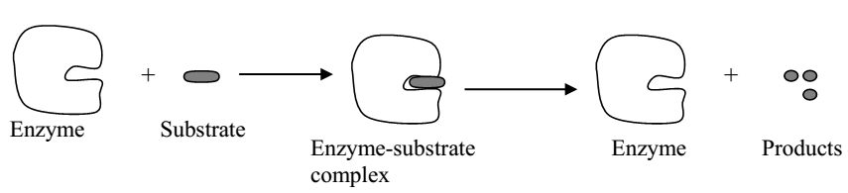

It is suggested that the active sites may not be exactly the same shape. It is believed that when the substrate combines with the enzymes, it causes a small change to occur in the same shape of the same shaped enzyme molecule thereby enabling the substrate to fit more in the active site. This is known as ***induced fit.***

The hypothesis says that when the substrate molecule enters the active site, it causes the enzyme to change its shape so that the two molecules fit together more tightly.

**Enzyme inhibitors**

Enzymes may be inactivated by substrates called inhibitors which interfere with catalytic processes. This effect may be produced in several ways.

1. Active sites at the enzyme may be blocked by the formation of the enzyme inhibitor complex. This is known as ***competitive inhibition*** and occurs when inhibitor molecule is structurally similar to the usual substrate of the enzyme.
2. The inhibitor may react irreversibly with the enzyme to form an inactive non-enzymatic end product.
3. The inhibitor may alter the shape of the enzyme at its point of activity so that the enzyme substrate complexes cannot form. This is known as non-competitive enzyme inhibition.

**Allosteric enzymes**

These are enzymes that occur in two forms, i.e. active and inactive.

The inactive form is shaped in such a way that the substrate will not fit into its active sites. Therefore for such enzymes to work, it must be transformed into the active form.

Allosteric enzymes can be inhibited by molecules which do not combine with the active site but with the other parts of the enzyme. In this case, the inhibitor prevents the enzymes from changing into the active form, and substrates which bring about this are known as allosteric inhibitors.

**Co-factors and prosthetic groups**

In some instances an enzyme must be associated with smaller molecule in order to function properly. Such molecules are known as co-factors. The co-factors may be inorganic like metal ions or organic substances like nucleotides.

A co-enzyme acts as a carrier for transferring chemical groups from one enzyme to another. Examples of co-enzymes include Nicotinamide Adenine Dinucleotide (NAD).

Sometimes the function of the enzyme is carried out by a non-protein group, known as prosthetic group e.g. cytochrome oxidase has an iron prosthetic.

**Classification of enzymes**

Enzymes are classified depending on the type of reaction they catalyze. The following are some of the classes of enzymes.

1. **Isomerase;** these catalyze reactions involving isomerism
2. **Phosphorylases**; these catalyze reactions involving addition of a phosphate
3. **Hydrogenases;** these catalyze reactions involving addition of hydrogen.
4. **Dehydrogenase;** these catalyze reactions involving removal of hydrogen.
5. **Kinases;** these catalyze reactions involving movement of molecules from one area to another.
6. **Carboxylases;** these catalyze reactions involving addition of Carbon dioxide.

Enzyme can also be described as being intracellular or extracellular. Intracellular enzymes are those which catalyze reactions inside the cells producing them, e.g. all respiratory enzyme are intracellular. Extracellular enzymes are those produced by a cell to catalyze reactions outside that cell. All digestive enzymes in man are extracellular.

**Nomenclature of enzymes**

Enzymes are named by adding a suffix “ase” to their substrates. A substrate is a substance, which the enzyme acts upon, or simply it is the raw material for the enzyme.

**Examples of enzymes and their substrates**

|  |  |
| --- | --- |
| **Enzyme** | **Substrate** |
| Peptidase | Peptides |
| Lipase | Lipids |
| Maltase | Maltose |
| Sucrase | Sucrose |
| Lactase | Lactose |
| Cellulase | Cellulose |

Some enzymes however retained their names they had before this convention. Such enzymes include pepsin and trypsin.

Sometimes the enzymes digesting carbohydrates are generally called carbohydrases and those digesting proteins as proteases.

**PROPERTIES OF ENZYMES**

1. They are all protein in nature.
2. They are specific in their action i.e. they catalyze specific food i.e. Maltase on Maltose.
3. They speed up the rate of chemical reactions (they are catalysts).
4. They are effective even in small amounts.
5. They remain unchanged at the end of the reaction.
6. They are denatured by high temperatures since they are protein in nature and are inactivated by low temperatures.
7. They are inactivated by inhibitor chemicals (poisons e.g. cyanide).
8. They work at a specific PH. (either acidic or alkaline).
9. Their reactions are reversible.
10. Their activity can be enhanced by enzyme activators e.g. chloride ions activate amylase.

**FACTORS AFFECTING ENZYME ACTIVITIES**

To investigate the effects of a given factor on the rate of enzyme controlled reactions, all other factors should be kept constant and at optimum levels so as to obtain accurate results.

The factors are:

1. Temperature
2. Concentration of the substrate
3. PH of the medium
4. Presence of activators
5. Presence of inhibitors
6. Concentration of the enzyme
7. **Concentration of substrate:**

A substrate is a substance (food) acted upon by the enzyme to form simpler products.

The rate of enzyme reaction increases with increase in substrate concentration and enzymes work slower when the substrate concentrations low.

However, further increase in substrate concentration will not increase enzyme reaction rate since all its active sites are fully saturated with food.

**A graph showing how the rate of reaction varies with substrate concentration**

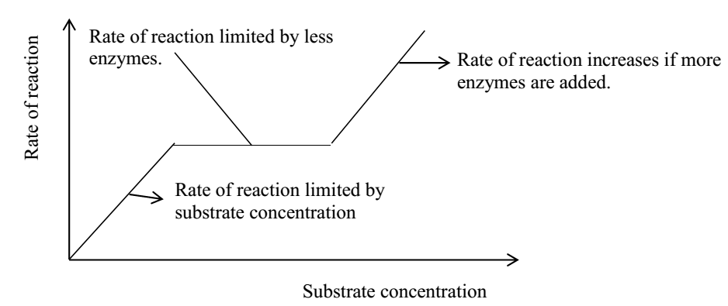

1. **Temperature:**

Enzymes work best at optional temperatures of (approximately 370 C). At very low temperatures, the rate of enzyme reaction is very slow because the enzyme is inactive at such low temperatures.

As the temperatures increase, the rate of reaction also increases gradually until it attains a peak where it has maximum activity and this always correspond at optimal temperatures. An optimal temperature is which promotes maximum enzyme activity. However with further increase in temperature, the rate of reaction decreases exponentially, sharply, steeply since at high temperatures, the enzyme is denatured ie the active site of the enzyme which is (protein in nature) is a altered (changed) or completely destroyed.

**A graph showing the variation of enzyme activity with temperature**

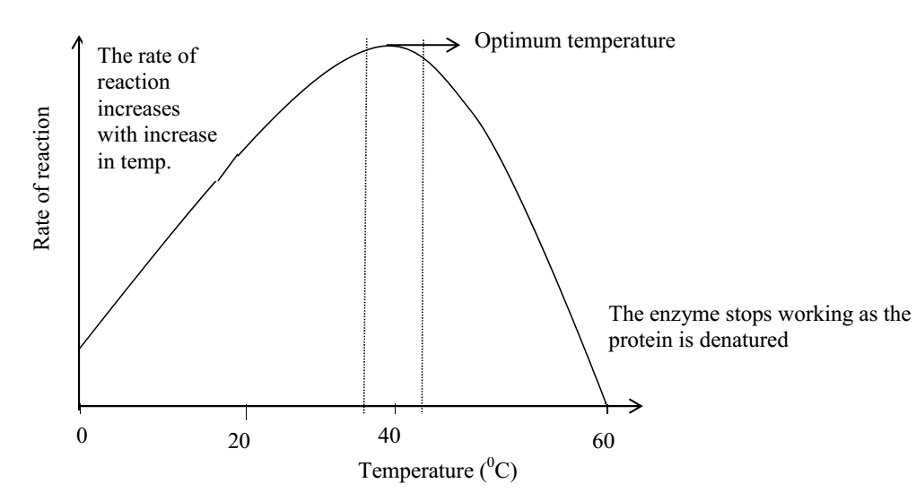

1. **Enzyme concentration:**

As the concentration of the enzymes increases, the rate of reaction also increases until all the substrates are being acted upon when the rate finally becomes constant.

**A graph showing variation of enzyme activity with enzyme concentration**

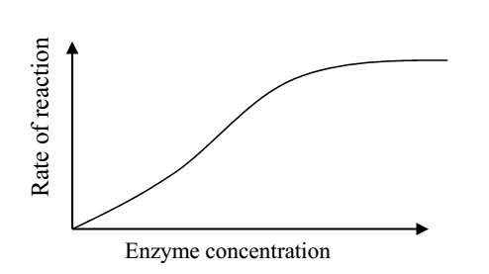

1. **The PH of the medium.**

Enzyme reactivity is reduced or stopped completely if placed in a medium whose PH is different from that in which it works best (optimum PH).

PH varies slightly above or below an enzyme’s optimum PH resulting in a marked fall in the enzyme efficiency. E.g. pepsin enzyme in the human stomach has a maximum activity with in acidic pH of 1.5 and 2.5 while the enzymes in the duodenum e.g. trypsin work at maximum with in alkaline pH of 8.5 to 9.5.

**A graph showing variation of different enzyme activity with PH**

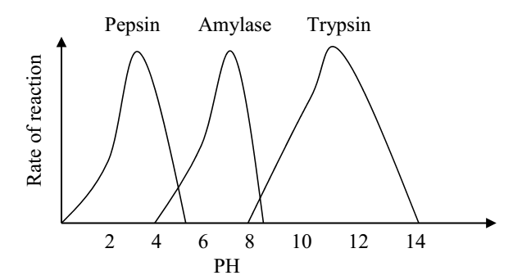

1. **Presence of enzyme inhibitors**

Enzyme activities decrease in presence of enzyme inhibitors and increase in their absence.

1. **Presence of activators**

Enzyme activators increase with presence of enzyme activators and decrease with absence of enzyme activators.

**NUCLEIC ACIDS**

These are made up of chains of individual units called nucleotides. Nucleic acids carry the genetic code that determines the order of amino acids in proteins. Genetic material stores information, can be replicated, and undergoes mutations.They differ from proteins as it has phosphorus and **NO** sulphur.

There are two types of nucleic acids i.e.

1. DNA (Deoxyribo Nucleic Acid)
2. RNA (Ribo Nucleic Acid)

Both types of nucleic acids are present in the nucleus of the cell.

DNA is found only within the nucleus while RNA is found within the nucleus (nucleolus) and in the cytoplasm.

RNA is usually associated with ribosomes and responsible for protein synthesis.

RNA is one stranded while DNA is double stranded hence having a higher molecular mass than that of RNA.

**The nucleic acid structure**

These are big molecules built from 3 types repeating sub-units i.e.

1. Nitrogenous bases (purines and pyrimidines)
2. Pentose sugars
3. Phosphate units.
4. **PURINES AND PYRIMIDINES (NITROGENOUS BASES)**

These are organic bases which belong to a series of related compounds in which the rings contain both carbon and nitrogen atoms.

The purines i.e. Adenine (A) and Guanine (G) are made up of two interconnecting rings while the pyrimidines i.e. Uracil (U). Cytosine (C) and Thymine (T) possess a single ring.

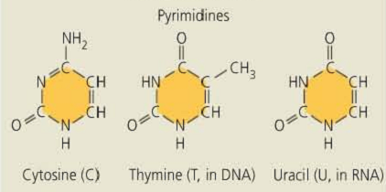

**Note:** They have single carbons and nitrogen rings

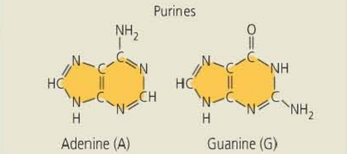

**Note:** they have double carbons and nitrogen rings

1. **THE PENTOSE SUGAR UNITS**

The pentose sugars are found in nucleic acids and are of two types i.e. ribose and deoxyribose. They differ only in that ribose sugars contain an additional oxygen atom.

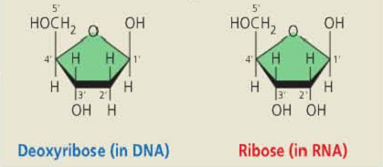

1. **PHOSPHATE UNITS**

These act as alpha links between one sugar group and the next.

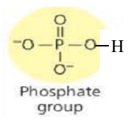

In nucleic acids, these 3 groups are linked together in a specific way to make a larger group as a nucleotide.

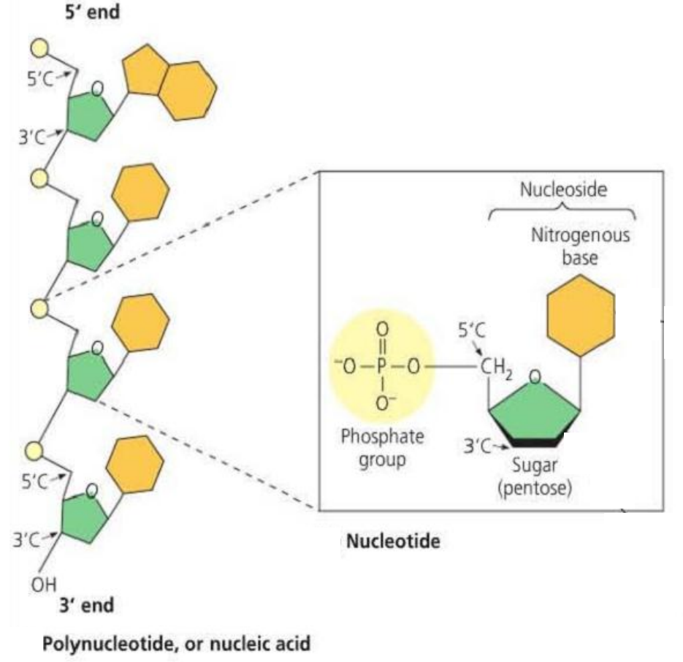

Many nucleotides are then joined by condensation to form a long chain known as a nucleic acid.

**RIBONUCLEIC ACID (RNA)**

The RNA molecule is made up of long chains of nucleotides incorporating the pentose sugar ribose and any of the four bases i.e. adenine and guanine (purines) or cytosine and thymine (pyrimidines).

The base uracil is found exclusively in RNA while the other bases also occur in DNA. RNA chains exist as single strands.

RNA exists in 3 types, i.e.

1. **Messenger RNA (mRNA)**

It forms an intermediate link between the nucleus and cytoplasm to facilitate the transfer of genetic information from the nucleus to the cytoplasm.

It is single stranded and forms 3-5% of the total RNA in the cell. mRNA is synthesized in the nucleus, a process known as transcription. It is synthesized of a DNA template after DNA has unzipped. Once completed, the mRNA strand then moves through the nuclear pore to the cytoplasm.

1. **Transfer RNA (tRNA)**

There is about 20 types of tRNA each coding for a particular amino acid. The function of tRNA is to pick up amino acids from the amino acid pool and delivering them to the site of protein synthesis i.e. on the ribosomes for alignment into polypeptides.

Structure of tRNA

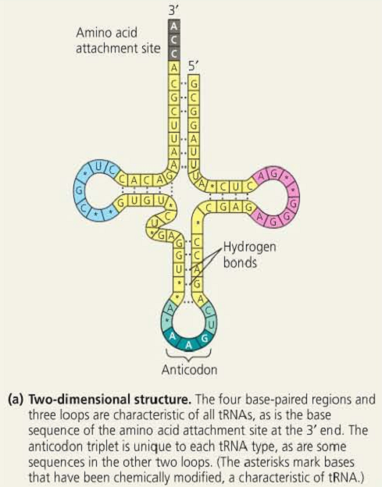

1. **Ribosomal RNA (rRNA)**

It is the most abundant in the cell forming 80% of the total RNA. It is found in the cytoplasm where it is associated with the protein molecules which together form the ribosomes that are assembling sites during protein synthesis.

rRNA plays an important role in translating the sequence of amino acids into a polypeptide chain in the cytoplasm.

**DEOXYRIBO NUCLEIC ACID**

This has a very high molecular weight and its structure is more complex than that of RNA. It is similarly made up of long chains of nucleotides but in this case, the sugar unit is a pentose deoxyribose and the pyrimidine base uracil is replaced by thymine.

DNA chains do not occur singly but paired together by weak hydrogen bonds across the bases to form ladder like constrictions. These bases can only link in a specific way where a purine must always link with a pyrimidine. In this case, adenine bonds with thymine while guanine bonds with cytosine.

Structure of the DNA double helix

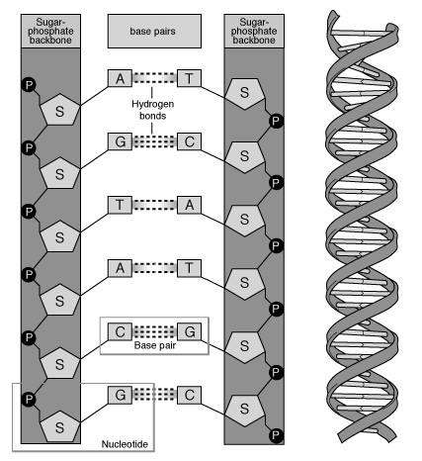

The partial chemical structure of DNA

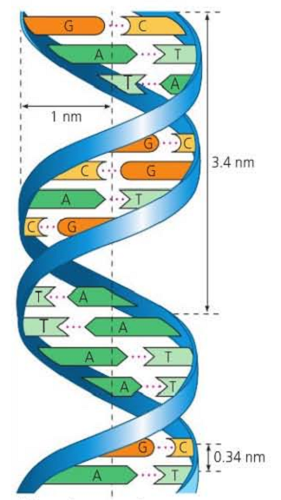

**Phosphorylated nucleotides**

The addition of a phosphate group to an organic molecule has the effect of increasing the reactivity of that molecule. Nucleotides may also require additional phosphate groups with an increase in reactivity. An example of this is Adenosine tri phosphate (ATP) which has two extra phosphate groups linked to the molecule by high energy bonds. This molecule acts as an energy carrier during several reactions.

**Other important nucleotides**

Many nucleotide derivatives act as co-enzymes acting in conjugation with other specific enzymes as carrier molecules by transferring a group of atoms from one molecule to another.

Nicotinamide adenine dinucleotide (NAD) is a phosphorylated derivative and Flavine adenine dinucleotide (FAD) both act as hydrogen carriers.

Co-enzyme A, also a nucleotide derivative acts as an acetyl carrier molecule.

**Similarities between RNA and DNA**

* Both contain guanine, cytosine and adenine.
* Both are found in the nucleus.
* Both are made of long chains of nucleotides.
* Both are made up of a base, sugar and a phosphate group.
* They both form the genetic material.
* Both of them contain four bases and two of them are derived from purines and the others from pyrimidines.

**Differences between RNA and DNA**

|  |  |
| --- | --- |
| **DNA** | **RNA** |
| Contains thymine | Contains uracil |
| Made up many nucleotide chains | Made up of a single nucleotide chain |
| Double stranded | Single stranded |
| High molecular weight | Has a low molecular weight |
| Has got hydrogen bonds | Lacks the hydrogen bonds |
| Found exclusively in the nucleus | Found in the nucleus and cytoplasm |
| It is of one type. | It is of three types i.e. mRNA, rRNA and tRNA. |

**PROTEIN SYNTHESIS**

Protein synthesis requires the supply of amino acids, energy and information. When these are grouped or brought together, proteins are synthesized in 3 types, i.e.

* Transcription
* Activation
* Translation

**Transcription**

This is the process of transferring part of the coded information of DNA in the nucleus to the ribosome in the cytoplasm. It involves a nucleic acid molecule made of RNA, known as mRNA, which is a single stranded molecule manufactured in the nucleus from one strand of DNA double helix referred to as coding strand.

The enzyme catalyzing the reaction of transcription is known as RNA polymerase. The beginning of protein synthesis starts by RNA polymerase attaching itself to the DNA double helix and the hydrogen bonds are broken down in the region of DNA to be coded (copied) and the DNA strand unwinds.

One DNA strand is then coded by base pairing of ribo-nucleotides, which are condensed together to form a strand of mRNA. The base sequence of mRNA is complementary to the coding strand of DNA. Once formed, the mRNA passes out into the cytoplasm and becomes attached to the ribosome.

**Amino acid activation**

Amino acids are activated for protein synthesis by combining with a short length of RNA known as transfer RNA (tRNA). The activation process involves ATP for provision of energy.

There are more than 20 amino acids coded for in all proteins. All tRNA have a globally leaf shape but differ in sequence of bases known as anticodon which is exposed on one of the leaves. This anticodon is complementary to the codon of mRNA.

Each type of tRNA binds with a specific amino acid. The amino acid molecules join to the free ends of tRNA molecules. The tRNA amino acid complexes now move to the ribosomes.

**Translation**

This process occurs in the ribosomes. It is mainly placing of the activated tRNA anticodon to the right mRNA codon by the ribosome in order to make a polypeptide chain.

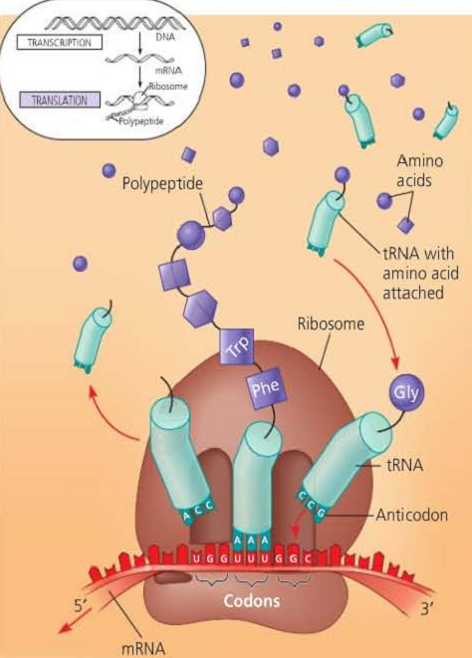

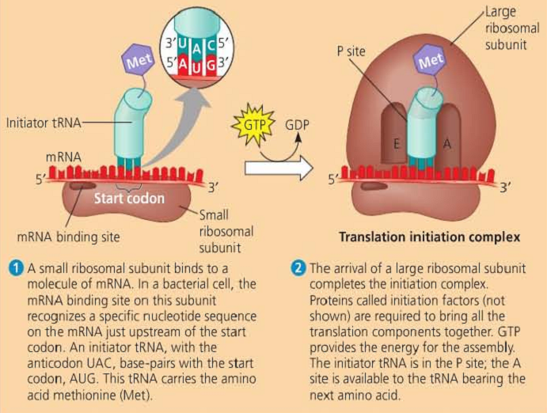

Ribosomes move along the length of the mRNA strand reading the codon from the start codon starting at one end of the mRNA molecule. A ribosome works its way along the mRNA positioning the anticodons of the tRNA on the complementary codon of the mRNA strand.

In the ribosome, complementary anticodons of amino acids, tRNA complexes are held in place by hydrogen bonds.

The amino acids are then joined by peptide bonds therefore meaning that the ribosome is acting as a supporting frame work, holding the mRNA and two amino acids.

tRNA complexes together and enables and enzyme to catalyze the formation of a polypeptide bond between the adjacent amino acids.

The ribosomes move along the mRNA and as it does it positions two activated tRNA having one amino acid at the same time.

The ribosome has two sides, A and P sides. At the starting codon, the side A is attached to the first tRNA which the P side is empty.

When it continues to move, a second tRNA attracts itself to the empty side corresponding to the second codon of mRNA.

The presence of the second amino acids on the second tRNA stimulates the formation of a polypeptide bond between the amino acids.

This makes the earlier tRNA to loose contact from the mRNA and its amino acids making it free going back to the cytoplasm.

For further activation, the ribosome continues to move along the codons of the mRNA, placing the activated tRNA in their right positions, together with their amino acids in the process forming a polypeptide chain which is released into the cytoplasm when the ribosome reaches the stop codon.

The protein structures are determined by the amino acids sequences.

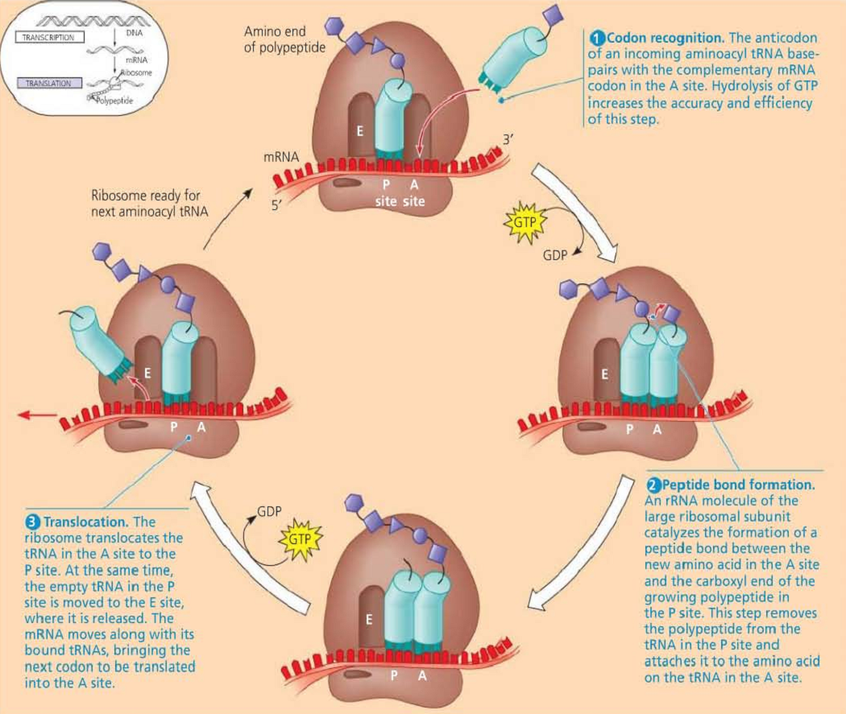

**Polysomes/polyribosomes**

These are groups of ribosomes, connected by a common strand of mRNA and synthesizing different types of polypeptide chains simultaneously. This arrangement means that several polypeptide chains are made at the same time, on one mRNA molecule.

When synthesis is completed, the polypeptides are moved from the ribosome to the cytoplasm and constructed into the proteins for internal use by the cell or for secretion.

**Diagram illustrating synthesis of proteins by polysomes**

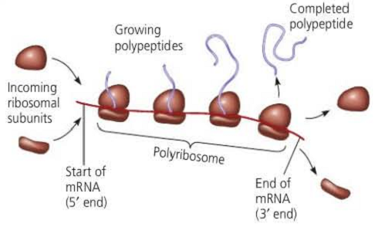

**Questions:**

1. *How does DNA regulate the synthesis of proteins? (protein synthesis but focus on DNA)*
2. *Outline the role played by the different types of RNA in protein synthesis.*

**THE GENETIC MATERIAL**

This is the material that is responsible for the transmission of hereditary traits or characteristics form one generation to another.

**Characteristics of a hereditary material**

1. It should be able to carry out self-replication i.e. make exact copies of itself for the onward transmission of its features to the off springs.
2. It should be stable in structure i.e. it should not change erratically losing its structure during transmission.
3. It should have the capacity to change i.e. to provide new material for creation of a new inheritance feature that can improve linkage of off springs. This can be done through mutation.
4. It should have the capacity to store information correctly preferably in a code which can be read and interpreted at an appropriate time.
5. It should be strategically located in the part of the body where it can be protected against metabolic reactions but have the ease to transmit information to all body parts e.g. in the nucleus.

**Evidence of DNA as a hereditary material**

Early researchers scrutinized many molecules in the body to find out which ones could have characteristics that fit the hereditary material. Proteins were seen as the best candidates since they were versatile in nature and were dominant in body parts. Proteins however are unstable as they constantly change and they are metabolically active and even not self-replicating.

Friedrich later eliminated proteins as the best candidate and identified a macro molecule he named ‘nuclein’ which appeared to satisfy most of the essential characteristics. Nuclein was later renamed DNA.

**Characteristics of DNA as a genetic material**

1. Consistency of DNA content in the nucleus. Diploid nuclei from cells in any species and at different stages of mitosis all contain the same quantity of DNA.
2. The gamete nuclei contain half the quantity as expected.
3. Unlike other cell components, DNA remains stable and intact as a large molecule.
4. DNA is not metabolized at any stage.
5. DNA has the capacity to mutate. Mutagens like U.V. light bring about changes in the DNA molecule which acts as a basis for new material of inheritance. Mutation is however limited and does not change the whole organism.
6. Presence of DNA in chromosomes which are the materials of hereditary.
7. Ability of DNA to replicate.

**DNA REPLICATION**

One of the most attractive features of DNA is that it can increase in amount before a cell divides. In order for DNA replication to occur, the two strands should be capable of unwinding. The process of DNA replication is catalyzed by enzymes.

**A model for DNA replication (the basic concept)**

In this simplified illustration, a short segment of DNA has been untwisted into a structure that resembles a ladder. The rails of the ladder are the sugar-phosphate backbones of the two DNA strands; the rungs are the pairs of nitrogenous bases. Simple shapes symbolize the four kinds of bases. Dark blue represents DNA strands present in the parent molecule; light blue represents newly synthesized DNA.

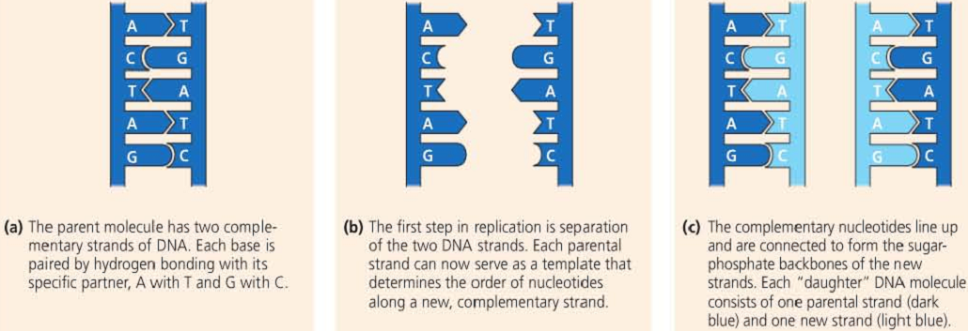

There are three hypotheses put forward to explain the process of DNA replication:

1. **The conservative hypothesis**

Here, no unwinding occurs but the DNA molecule acts as a stimulant to direct the reaction. All the DNA strands formed are directly similar but not complementary to the parental strands. This hypothesis has not received any scientific backing and appears impractical.

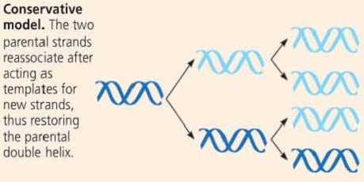

1. **The semi-conservative hypothesis**

The DNA double helix unwinds and produces two DNA strands. Therefore the parent molecule act as a template where by each strand is used to manufacture another complementary strand thus one strand is directly conserved and only one new strand is manufactured.

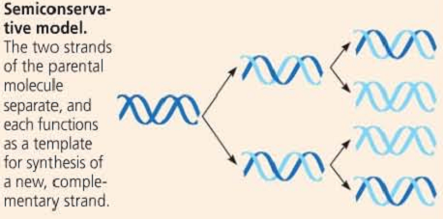

1. **Dispersive hypothesis**

According to the hypothesis, DNA initially disintegrates and then re-assembles alongside with the new complementary nucleotides adding to form new helices.

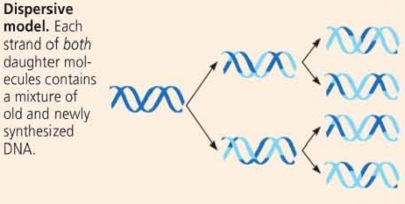

**Note:** Meselson and Stahl performed an experiment to find out whether DNA replication follows the conservative, semiconservative or dispersive model. They cultured E. coli for several generations in a medium containing nucleotide precursors labeled with a heavy isotope of nitrogen, 15N. They then transferred the bacteria to a medium with only 14N, a lighter isotope. Two samples were taken from this flask, one at 20 minutes and one at 40 minutes, after the first and second replications, respectively. They could distinguish DNA or different densities by centrifuging DNA extracted from the bacteria.

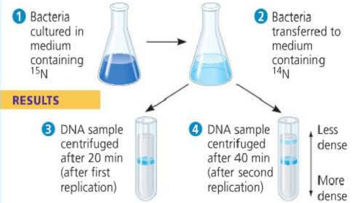

They then compared their results to those predicted by each of the three models.

The first replication in the 14N medium produced a band of hybrid (15N- 14N) DNA. This result eliminated the conservative model.

The second replication produced both light and hybrid DNA, a result that refuted the dispersive model and supported the semiconservative model. They therefore concluded that DNA replication is semiconservative.

**DNA AND THE CHROMOSOME STRUCTURE**

The chromosome structure depends upon the complexity of an organism. There are two levels of complexity and two types of chromosomes:

1. **Prokaryotic chromosomes:**

Prokaryotes have simple chromosomes but with a naked structure. Simple chromosomes are also found in chloroplasts, mitochondria of higher plants, blue green algae (cyanophyta).

1. **Eukaryotic chromosomes:**

They are in higher plants and animals. Each cell contains several pairs of chromosomes. The chromosomes are large and they change their form and structural organization at different stages of the cell cycle.

Each chromosome is made up DNA and an equal quantity of protein weight by weight. The DNA protein complex found in chromosomes is known as nucleoprotein or chromatin.

**Proteins in a chromosome**

There are two types:

1. **Histones:**

These are basic or non-acidic proteins that form the back bone structure of a chromosome on which the DNA is wrapped. The back bone structure of the chromosome on which the DNA is wrapped is called **octamer.** The types of histones are H1, H2A, H2B, H3 and H4.

1. **DNA:**

Eukaryotic chromosomes contain double helical DNA in large quantities. Replication of DNA in eukaryotic chromosomes occurs by the semiconservative method but would be very slow due to its length taking about 16 days to manufacture one strand.

To avoid the slow speed, DNA opens up as many as 6000 replication forks. Replication takes place at all the forks almost concurrently and the cycle is completed in 3-4 minutes.

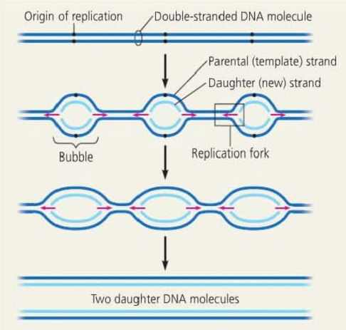

**DNA AND GENES**

**The genetic code**

This refers to the way genetic information is encoded or arranged on the DNA strand. It is a known fact that a lot of genetic information is stored and transmitted by the DNA molecule.

Such information is arranged in form of a code of base pairs on the DNA strand. To be able to utilize this information e.g. during the manufacture of amino acids, proteins, enzymes, hormones, etc. the code must be read and interpreted correctly and the secret information released and transformed into products.

**Reading the code**

A code (DNA) is usually located in the nucleus yet the products of reading it are found in the cytoplasm. Therefore, information has to be transferred from the nucleus to the cytoplasm in order to make the products. Both transfer and utilization of information is done through a special molecule called RNA. This is a nucleic acid that has the capacity to move out of the nucleus therefore transfer information.

**What is a gene?**

It is a unit of hereditary located on the positions called gene loci on the chromosome. Genes who code for polypeptides are of two groups:

1. **Structural genes:** these code for function of proteins e.g. enzymes, hormones, antibodies, etc.
2. **Regulatory genes:** these serve to control the activity of other genes.

The DNA strand has two regions;

1. The split gene area, which is the coded area and made up of coding sequences known as exons.
2. The non-coding area is made up of redundant DNA and is composed of non-coding sequences called introns. The function of introns is unknown.

**The code dictionary**

There are four bases on the DNA strand that are used for coding of amino acids. Their combination ought to give a coding total of 20 amino acids found in the body. If each base was on its own codes for an amino acid, only four amino acids would be coded. If the bases acted in pairs only 16 amino acids would be coded. In both cases, 20 amino acids are not arrived at it. It therefore appears reasonable to theorize that 3 base pairs are required for coding an amino acid.

Having established that each amino acid is determined by a triplet base pair, it has been used to establish and read the code dictionary. The three base pair hypothesis means that to code for the 20 amino acids occurring in the body, 64 possible combinations exist. The 44 combinations are not used in amino acid coding and are referred to as degenerate or nonsense codons/stop codons. Because of this, more than one but nearly similar triplet can code for an amino acid.

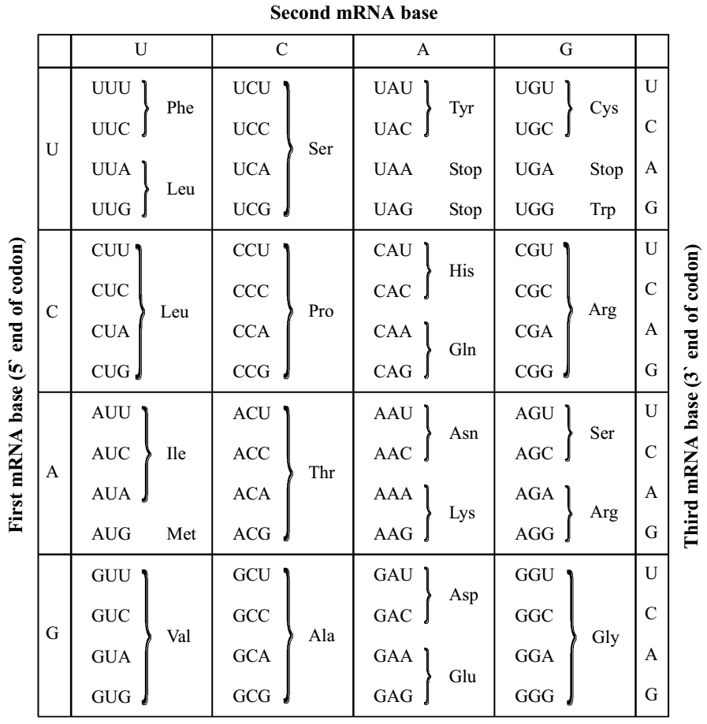

The three bases of an mRNA codon are designated here as the first, second, and third bases, reading in the 5` to 3` direction along the mRNA. () the codon AUG not only stands for the amino acid methionine (met) but also functions as a “start” signal for ribosomes to begin translating the mRNA at that point. Three of the 64 codons function as “stop” signals, marking the end of a genetic message.

**General characteristics of the genetic code**

1. The code is universal and the same codons are used to specify the same amino acids in all living organisms.
2. The code is degenerate i.e. more than one codon can code for one amino acid. Some amino acids like methionine and tryptophan are coded by only one codon but many others are coded by several codons. Therefore, a code has excess codons.
3. The code is non-ambiguous i.e. no one codon can code for more than one amino acid.
4. The genetic code is triplet i.e. it has got three bases.
5. It is collinear because the sequence of codons on the mRNA corresponds to that of the amino acid on the polypeptide chain.
6. The genetic code is non-over lapping except in some viruses.
7. Some triplet do not code for any amino acids i.e. they punctuate the process of protein synthesis.
8. The genetic code has initiation or start codons i.e. methionine.

**“Whatever the mind of man can conceive and believe, it can achieve” (N. Hill, 1983).**